National Sun Yat-Sen University
Department of Mechanical and Electro-Mechanical Engineering
Course Title: Stochastic Process and Modeling (MEME542)
Spring 2020

Final Project:

Topic: Independent Component Analysis for Blind Source Separation
Project's Introduction
The Independent Component Analysis (ICA) is a well-known method for blind source separation (BSS) in the field of signal processing. ICA is one kind of unsupervised learning approaches in machine learning which can separate a multivariate signal into additive subcomponents. It assumes that the sub-components are "non-Gaussian" signals that they are "statistically independent" from each other. Its algorithm design involves with the fundamentals of information theory, optimization, probability theory, and stochastic process. There are many methods that have been developed to fulfill the ICA. Two of the common used methods are Infomax method and Fast-ICA method, respectively.
In this project, students are requested to learn the basic mathematical concepts of the ICA algorithms, and requested to implement ICA algorithm on the blind source data.

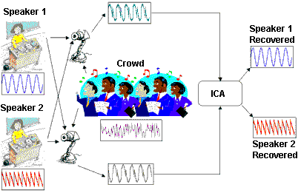
Fig.1 Blind source separation achieved by ICA.
Basic concepts of ICA
Give a mixed signal set , the ICA aims to find the linear representation of the non-gaussian data components, denoted by , which is statistically independent. (Note: The mixing matrix is generally unknown)

Fig.2 Mixture model of ICA.

Fig.3 Mixture model and unmixing model.

(a)
(b)

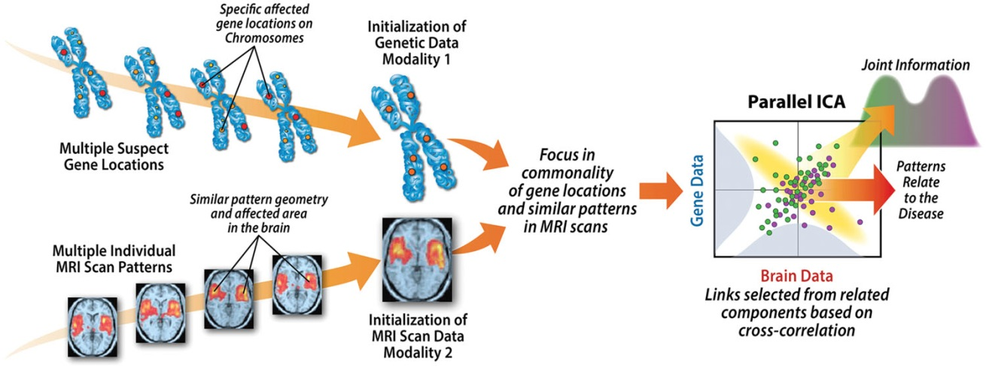
(c)
Fig.4 Related application (a) Mixed audio separation (b) Mixed image separation.(c) Medical data analysis.

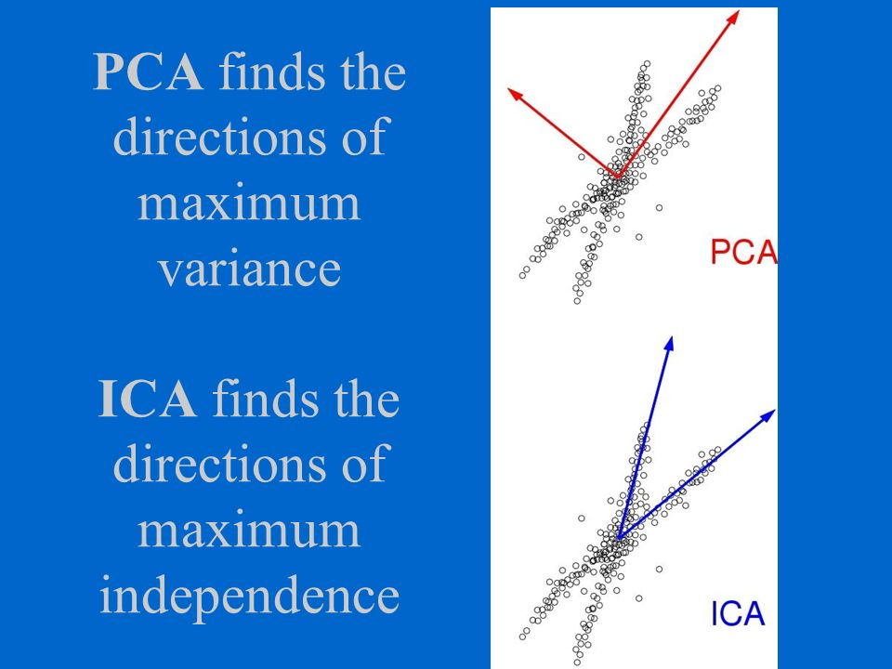
Fig.5 Difference between PCA and ICA.

ICA Algorithm
There are two major methods to achieve ICA. One is called Infomax, which was developed based on maximum likelihood estimation or minimization of mutual information. The other is called FastICA, which was developed by maximizing the nongaussianities measured by the approximation of "negentropy" under a fixed-point iteration procedure. In general, the FastICA has the following main advantages over Infomax:
(1) Fast convergence;
(2) Less parameters to be set;
(3) Independent component can be estimated one by one;
(4) Can be implemented in parallel structure.

Fig.6 Optimization steps of FastICA.

Data Acquisition
Students can use any kinds of blind source (mixed) data, such as audios, images, or other experimental signals. Either ready-made data or self-made data can be used. Students are more encouraged to use the self-made data which is relevant to your their own research fields.

Software/Code package
In this project, students are asked to implement the ICA algorithm on their own collected blind source data. The ICA codes can be easily found in internet. For instance, the FastICA's Matlab (or C++) code can be found at website: http://research.ics.aalto.fi/ica/fastica/

Except for using the publicly available codes, students can build their own ICA code based on the equations of the papers or reference books. In this case, extra credits will be given to the grade of the project.

Report Format
The project report will count for 50% grade in this project. The total number of pages is limited to 10 pages. Some contents should be included:
1. The introduction to ICA (basic model, assumption, etc), and the relationship to the theorem of stochastic process
2. The adopted method (algorithm and code) the theoretical description
3. Experiments (including data introduction and experimental results)
4. Observations, interesting findings, and discussions.
*Please write the report in an academic format. It should include abstract, introduction, methodology, experiment (data description, method, parameter setting, software/hardware details), discussion, and conclusion.
*Deadline is June 27

Oral Presentation
Students need to present your own work in the last class (June 22) of the semester. For one student, 6-8 min will be given. This part will count for 50% grade in the project. Using a powerpoint slide to present is suggested. Also, the supportive devices and materials can be brought to class and demonstrated.

Reference
‧A. Hyvärinen and E. Oja, “Independent component analysis: algorithms and applications,” Neural Netw, vol. 13, no. 4–5, pp. 411–430, Jun. 2000.
‧A. Hyvärinen, J. Karhunen, and E. Oja, Independent Component Analysis, 1 edition. New York: Wiley-Interscience, 2001.
‧D. Langlois, S.Chartier, and D.Gosselin, “An introduction to independent component analysis infomax and fastica algorithms,” Tutorials in Quantitative Methods for Psychology, vol. 6(1), p. 31-38, 2010.
‧[Fast ICA code] http://research.ics.aalto.fi/ica/fastica/
‧[Code and demo] http://cnl.salk.edu/~tony/ica.html
‧[Infomax ICA code] http://cogsys.imm.dtu.dk/toolbox/ica/#icaML
‧http://en.wikipedia.org/wiki/FastICA
‧http://en.wikipedia.org/wiki/Independent_component_analysis
‧http://research.ics.aalto.fiicafastica
‧http://sccn.ucsd.edu/~arno/indexica.html
‧http://fourier.eng.hmc.edu/e161/lectures/ica/node7.html

